The haunting similarities Lindsay Clancy murder trial has with case of Irish mother who killed her three young children
- See more Daily Mail on Google - save us as a Preferred Source
By ARTHUR PARASHAR, SENIOR REPORTER
Published: 10:22 BST, 5 September 2026 | Updated: 13:11 BST, 5 September 2026
175
View comments

The murder trial of Lindsay Clancy has both captivated and divided America for the last five weeks.
It is not disputed that the 36-year-old, from Duxbury, Massachusetts, strangled her three children Cora, five, Dawson, three, and eight-month-old Callan, to death on January 24 2023.
Rather 'America's saddest trial' hinged on whether Clancy was 'criminally responsible' for the killings or had a rare mental condition known as 'postpartum psychosis'.

00:02
02:24
Read More
Clancy has seen hundreds of supporters, dressed in pink shirts, protesting each day outside court arguing she should never have been put on trial, while a fundraiser has raised more than $1million. Others have demanded a murder conviction.
Last night, after five weeks of prosecution and defence lawyers arguing their cases, Judge William Sullivan declared a mistrial after the jury failed to reach a unanimous decision at the end of seven intense days of deliberations.
Clancy, a former labour and delivery nurse, is not the first mother to be accused of murdering her children – but the trial sparked a passionate debate about whether such women are criminals or victims.
In a lesser known case, Irish mother Deirdre Morley was charged with murdering her three children Conor, nine, Darragh, seven, and Carla McGinley, three, at their home in Newcastle, County Dublin, in 2020.
The distressing case has eerie similarities to Clancy's – with both triple child killings even taking place on the same day of the year – yet Ms Morley's murder trial played out entirely differently.
Both women were nurses and mothers of three young children. They both had documented mental health problems before the killings. And both killed all of their children in their family homes on January 24 before attempting to take their own lives.
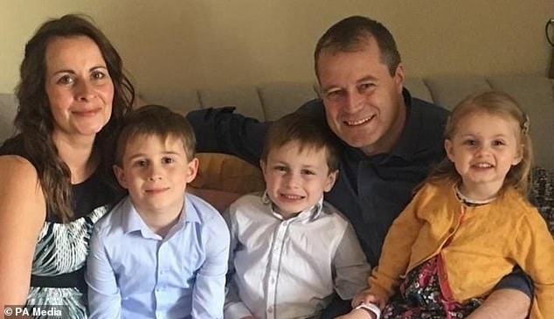
+10
View gallery
Deirdre Morley, 44, killed her three children Conor McGinley, nine, Darragh McGinley, seven, and daughter Carla McGinley, three, by smothering them at their home in January 2020
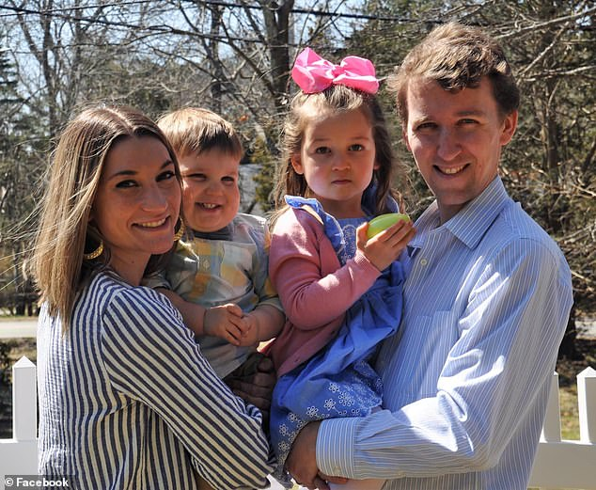
+10
View gallery
Lindsay Clancy (left) with her ex-husband Patrick (right) and their children who she strangled to death
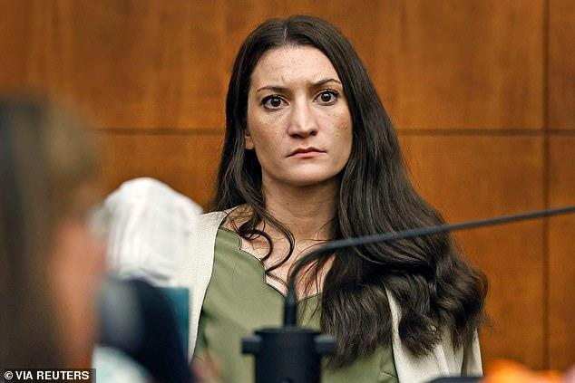
+10
View gallery
The murder trial of Lindsay Clancy has both captivated and divided America for the last five weeks
On January 24, 2020 – three years to the day before Clancy killed her children – Ms Morley smothered her children to death at their home. The bodies were discovered by their father Andrew McGinley, like Patrick Clancy – who found his children dead at home in the Boston suburb of Duxbury.
Mr McGinley told The Irish Mirror last week: 'I empathise with them both (Clancy and her ex-husband Patrick) in that people are choosing sides. That's what happened in our case. But what people need to do is to understand the facts.'
Ms Morley, who worked as a paediatric nurse, pleaded not guilty by reason of insanity during her murder trial at the Central Criminal Court in Dublin, Ireland.
She had a severe psychotic depressive illness. She was suffering bipolar affective disorder type two, a recognised mental disorder.
This trial had no huge culture war, nor were there protests and endless debate on social media.
The jury of ten men and two women were told that they must be satisfied, on the balance of probabilities, that Ms Morley was suffering from a mental disorder when she killed her children.
The judge, Mr Justice Paul Coffey, said the jury had to be satisfied that the mother did not know what she was doing was wrong or was unable to stop.
They heard from expert witnesses, from both the prosecution and defence, who were unanimous in their view that Ms Morley was legally insane when she killed her children. There was no dispute between the sides and therefore nothing to set against the doctors' opinion.
The prosecution and defence agreed that the mother should be found not guilty. And so she was acquitted on all three counts by reason of insanity and remanded to the Central Mental Hospital in Dundrum, Co. Dublin.
Ms Morley had previously suffered a breakdown in July 2019 and spent four weeks in a psychiatric hospital.
The tragic triple killing took place on January 24 2020 when Morley had slipped into a state of delusion and psychosis.
In Clancy's case, the killings occurred less than three weeks after she was discharged from a psychiatric hospital. Her defence argued she was suffering from postpartum psychosis when she strangled her children so could not be held criminally responsible.
The prosecution argued that the killings were intentional, calculated and murder.
Yet in Ms Morley's case, the psychiatric experts for both the prosecution and defence agreed that she was legally insane when she killed her children.
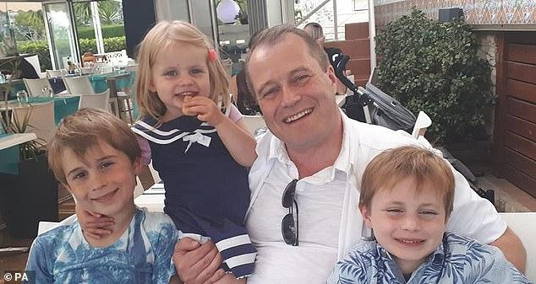
+10
View gallery
Mr McGinley and his three children, who were killed by their mother Deirdre Morley
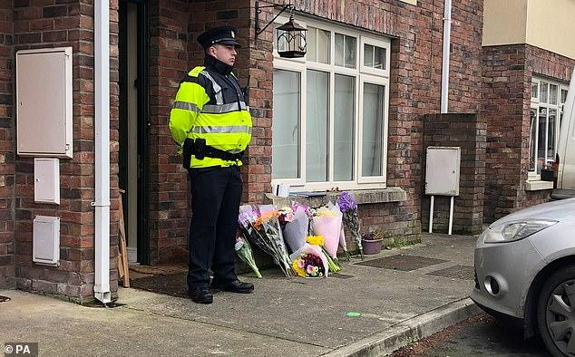
+10
View gallery
The children's bodies were discovered by their father Andrew McGinley at their home in Parson's Court, Newcastle, Co Dublin
Before suffocating them, she had tried to sedate them, wanting to die and take her children with her.
The night before the tragedy, she put morphine in the boys' cereal and Carla's bottle but they spat it out.
The following day, she first killed Darragh, who was at home from school because he was ill.
In interviews with gardaí (Irish police), she said she could recall thinking: 'I could smother him now. I could kill him now.'
She said she immediately regretted killing Darragh and wanted to stop, but felt she couldn't as she 'couldn't leave any of them behind'.
After suffocating Darragh and Carla using tape and plastic bags, she collected Conor from school.
He was watching Jurassic World in a play tent back home when she approached him with the bag and tape.
She suggested playing a game where they put tape on their mouths and try to speak.
When she put the bag on his head, he said: 'Stop mammy, what are you doing?' but she replied, I'm sorry Conor.'
Morley told police he had not struggled as she was lying on top of him.
At one stage she said she thought, 'I can't do this. This is awful. But also that I can't not do this' because Conor's siblings were already dead.
The mother was unable to carry his body upstairs to lie next to his younger brother and sister.
Throughout the day, she spoke to her husband on the phone and he said he had no suspicions about her wellbeing or her behaviour.
Morley then decided to take her own life, and drove towards the M7 with a bottle of wine and medication in the car before she crashed at a roundabout.
Clancy also attempted to take her own life, throwing herself out of a first floor window. She is now confined to a wheelchair after the fall left her paralysed.
Ms Morley was brought home by a passing nurse before she left the house again and was found by a taxi driver 'wandering the streets' in a 'disoriented state'.
The driver took her home and called an ambulance out of concern, as Mr McGinley returned from a work trip to Cork to find the bodies of his three children.
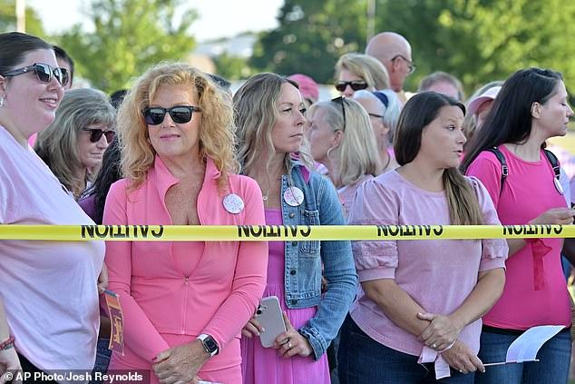
+10
View gallery
Supporters of Lindsay Clancy stand outside Plymouth Superior Court wearing pink
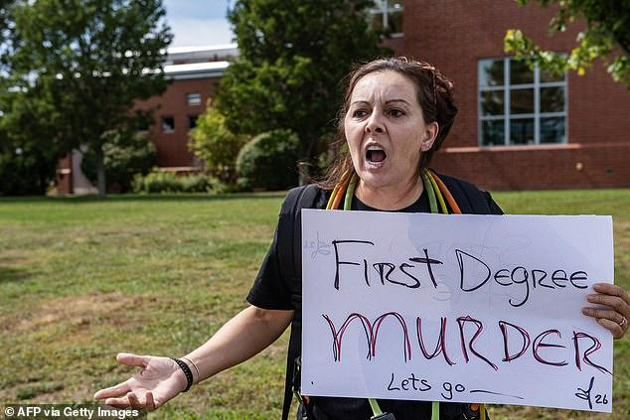
+10
View gallery
Others have called for a murder verdict in a trial which has divided the country
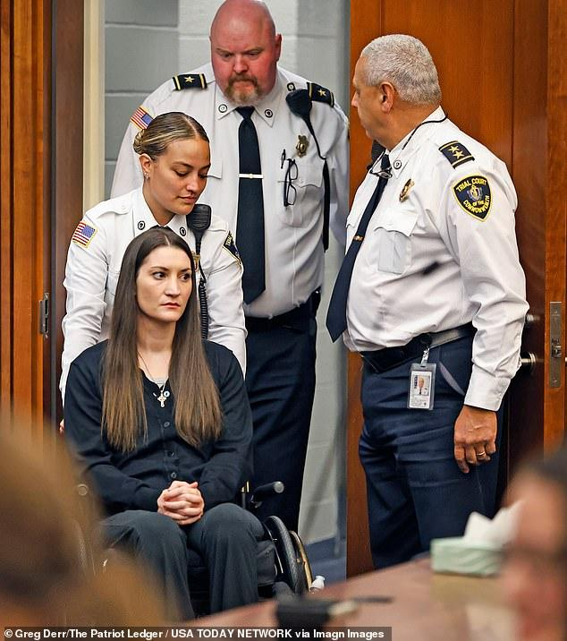
+10
View gallery
Lindsay Clancy was paralyzed from the waist down following her suicide attempt
He also found a note warning not to go upstairs, saying 'I'm sorry.'
Morley was taken to Tallaght University Hospital in Dublin where she later told medics she 'wished she had a time machine'.
Mr McGinley told Irish broadcaster RTE that he accepted that his wife was not in her right mind when she killed their children.
'We had nearly 20 years together. Dee loved the kids,' he said.
However he said he would never be able to break the connection between her and what happened, adding: 'I'm going to struggle with that every single day. I really am.'
After the death of his children, Mr McGinley told parents to 'cuddle your children whenever you can' and admitted 'every breath is a struggle.'
He said: 'There are no words. There is only devastation, grief and anguish. Every breath is a struggle.
'Conor, Darragh and Carla are adored. They all had beautiful, bright futures ahead of them with family, friends and a community who love them.
'To all parents, cuddle your children whenever you get a chance, tell them how much you love them as often as you can, spend every spare minute with them reading, playing and enjoying their wonderfulness.
The future has now become our enemy but we will battle it every day to keep the memory of Conor, Darragh and Carla alive.'
Giving a eulogy at his children's funeral, he also said his children had been fans of Lego, the Foo Fighters and the Disney film Frozen.
He went on: 'We often misuse words. When Ireland would lose a match, I used to say I was heartbroken. I now know what that really means.
'We, as a family, are heartbroken.'
He added: 'Conor, Darragh and Carla. I love you, I love you, I love you.'
In 2022, Ms Morley and Mr McGinley both launched legal action over medical negligence.
“I want to understand why my children died. Two years on from their deaths and I’m still no clearer,” Mr McGinley told the Irish Examiner at the time.
Mr McGinley has been campaigning for better mental healthcare in Ireland.
Ms Morley is understood to still be in the care of the Central Mental Hospital.
Lindsay Clancy
Share or comment on this article: The haunting similarities Lindsay Clancy murder trial has with case of Irish mother who killed her three young children
Add comment

