Skills and Pills for Depression: What Works and What Hurts, and How to Talk About It
Saturday, October 4, 2025 1:00pm - 5:30pm
Grand Ballroom, Joe Crowley Student Union
University of Nevada Reno
1664 N. Virginia Street, Reno NV 89557
Co-Sponsored by:
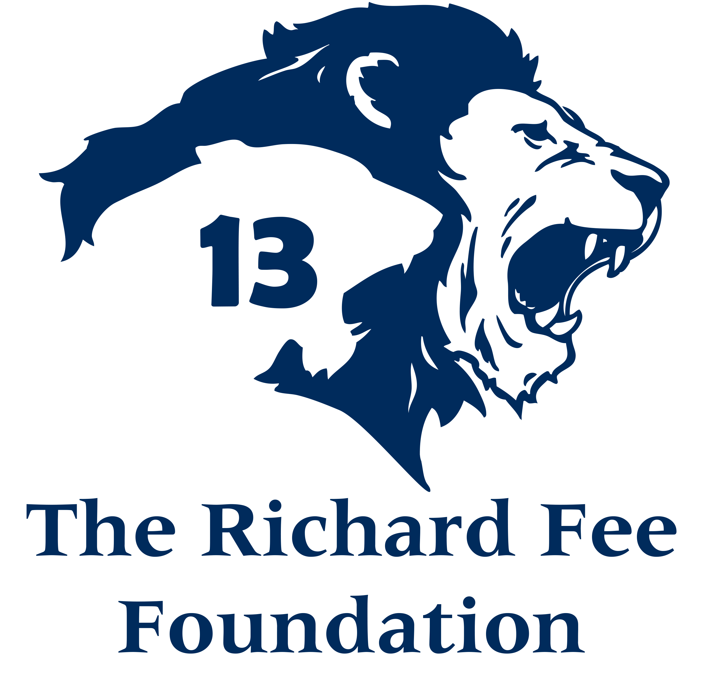 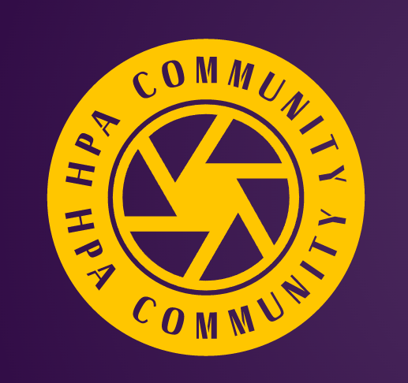 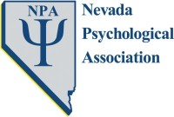 About the Workshop:
The goal of this conference is to engage professionals, both prescribers and non-prescribers, members of the public, and introductory psychology students in a discussion of the scientific evidence regarding how medications compare with nondrug treatments for depression, and how patients can effectively collaborate with their doctors about their choices when seeking treatment for depression, in order to maximize benefit and minimize risk.
Learning Objectives:
At the end of this workshop, attendees will be able to:
1) Understand the differences between the FDA and FAA (Federal Aviation Authority) and the implications for them.
2) Learn at least 2 key details about the history of antidepressants and RCTs.
3) Cite the landmark NEJM study (Turner et al., 2008) and specify what percentage of antidepressant trials were judged to be positive as analyzed by the FDA.
4) Know how many positive trials the FDA requires in order to approve a new medication for a specific use.
5) Articulate what led the FDA to impose a Black Box Warning that antidepressants can cause suicidal behavior.
6) Identify and address at least one specific physiological antidepressant side effect that is thought to be connected to suicidal behavior.
7) Cite at least 2 studies comparing psychological interventions with antidepressants.
8) Specify at least 2 scientifically supported specific psychological interventions for depression.
9) Ask 2 specific questions of their doctor to help appropriately guide their treatment choices.
10) Walk away with a copy of a model informed consent template they can modify for their own use.
11) Devise at least 2 ways to intervene effectively when treatment goes wrong.

