The NY Times suddenly discovered we’re giving kids dangerous drugs
By Karol Markowicz August 29, 2022 9:52pm Updated
Suicide rates in ages 10 to 24 rose 60% from 2007 to 2008.Getty Images/iStockphoto
Why does obvious damage to children go ignored for so long?
Over the weekend, The New York Times had a splashy story about the overmedication of children. It was only 20 years late.
Writer Matt Richtel tells the story of Renae Smith, a high-school freshman who was prescribed ever more psychiatric drugs for her anxiety and depression until she was taking 10 different medications.
Pointing out that “many psychiatric drugs commonly prescribed to adolescents are not approved for people under 18,” the story quotes Lisa Cosgrove, a University of Massachusetts, Boston clinical psychologist: “You can very cogently argue that we don’t have evidence about what it means to be on multiple psychotropic medications. This is a generation of guinea pigs.”
This is horrifying. This is a travesty. This is a very old, known problem.
In fact, the Times piece points to decade-old studies showing teen psychiatric-drug use has been on a sharp trajectory upwards for a long time now. “A nationwide study published in 2006 examined records of visits to doctors’ offices by people younger than 20 and found a sharp rise in office visits involving the prescription of antipsychotic drugs — to 1.2 million in 2002 from 200,000 in 1993.”
Everyone knew this was happening, and we knew it was bad.
As antidepressant use in children has skyrocketed, so has suicide. Suicide rates for those aged 10 to 24 rose 60% from 2007 to 2018, the Centers for Disease Control and Prevention reports, and climbed even higher during the pandemic.
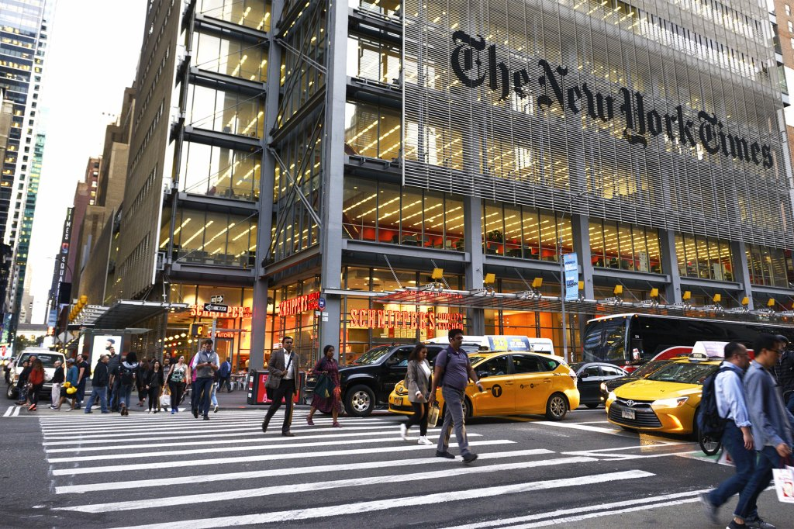The New York Times published an article detailing a high schooler who was prescribed 10 different medications.Getty Images
This isn’t a tenuous link. In 2005, the Food and Drug Administration added a “black box” warning that antidepressants can cause suicide. Two years later it updated the warning specifically to include children and adolescents.

SEE ALSO
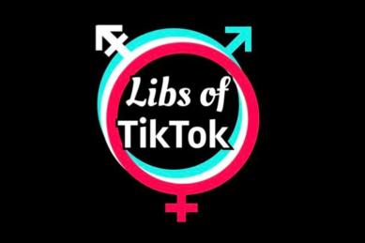

Facebook bans ‘Libs of TikTok’ after Boston children’s hospital gets threats

Conservatives have been saying this for years. In fact, just last month when Tucker Carlson argued SSRIs, or selective serotonin reuptake inhibitors, a type of antidepressant, are being overprescribed, the headlines attacked him.
“Why The Far Right Is Going After Antidepressants,” screeched The Huffington Post while Rolling Stone squalled, “The Far Right’s Next Target for a Bulls–t Moral Panic.”
Looks like The New York Times is far right now.
The larger issue isn’t so much the politicization of something like medicine, though that certainly is a problem. It’s that we have to pretend things that are obviously bad, like teenagers being prescribed nearly a dozen hardcore psychiatric pills, are OK while we all know they’re not.
It’s also hard not to notice a similarity to another guinea-pig experiment run on children. Boston Children’s Hospital was forced to update its website this month when it emerged it was offering “gender-affirming hysterectomies” to minors. The update said one had to be 18 to have one’s cervix, uterus and fallopian tubes removed.
An 18-year-old can’t legally smoke cigarettes or drink alcohol — but completely altering his or her body is acceptable, and anyone who says, rightly, that this is horrific is called a transphobe.
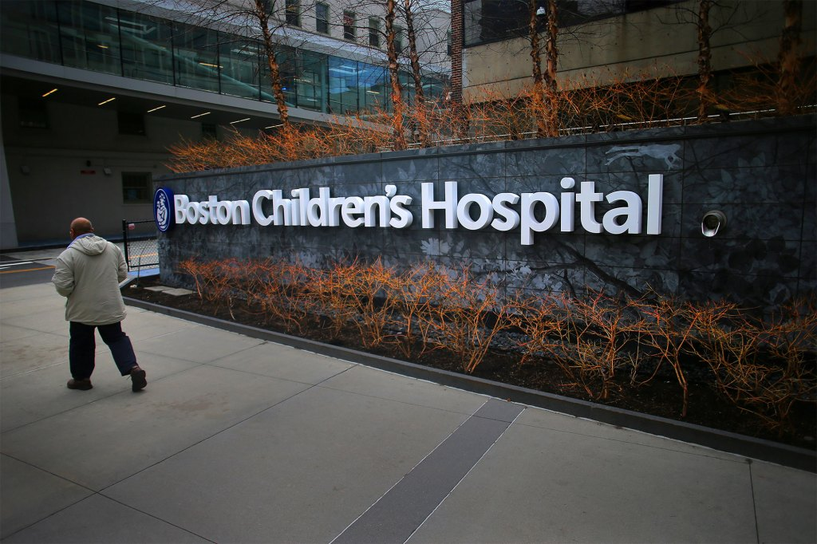Boston Children’s Hospital was recently under fire for offering “gender-affirming hysterectomies” to minors.Lane Turner/Boston Globe via Getty Images
And other experiments are conducted on kids far younger. Puberty blockers have been all the rage in the medical community for many years. St. Louis Children’s Hospital advertises that its Transgender Center offers the blockers that “can delay unwanted changes like breast growth, facial hair, periods and voice deepening” along with “hormone therapy to help a person’s body match their gender identity.”
This combo can stunt growth, prevent the person from ever having an orgasm and lead to sterility. Yet experimenting on these guinea pigs continues.
We know this is crazy, same as we know that kids taking fistfuls of antidepressants is crazy. We don’t need The New York Times to finally realize it a few decades from now. These are our children, and they deserve far more care and attention than they’re being offered by the medical establishment. First, do no harm. But first, stop doing harm to children.
Twitter: @Karol
- OHarriet
16 hours ago
It's not just kids. My neighbor is 32 and takes 7 scripts a day, two of them twice a day. She was diagnosed with anxiety. 7 prescription meds to treat anxiety. And two of the pills are to treat side effects of the other 5. Seriously?
- Lola
11 hours ago
Also check into the fact that psychiatrists can't bill unless they have a diagnosis and treatment plan, which must include a medication. That's a huge problem. Then, GP's aren't qualified to prescribe psychotropics, and it's malpractice for any doctor to diagnose and prescribe without a proper examination, and GP's cannot properly examine mental health, but they get paid to dispense the pills, and people WANT the pills. Another huge problem -- people not wanting to feel like normal human beings. We've been taught that normal human sadness or anxiety are wrong and must be medicated away. Now we have zombies shrieking on Twitter about THE FEELS!!!! when really they can't feel at all.
  - Jose Quervo
6 hours ago
Im just going to repeat something from above : We've been taught that normal human sadness or anxiety are wrong and must be medicated away. Correct. Its okay to have a crappy day or 5 . The sun will come out . Hang in there. Find a hobby. Get involved with something . Get rid of toxic people dragging you down. You can do it!!
- DaRev
17 hours ago
Trans drugs alone are a million dollars during the lifetime of the patient, and then add surgery and other drugs to maintain and it is 1.5 million lifetime per patient, so is it any wonder that doctors and Big Pharma wish to Trans the world? If they have complications that is just more money.....
- DiNapoli's a Fraud
9 hours ago
The whole pschiatrist/psychologist "profession" is a huge scam that has only grown due to the over-medication of children. Their goal is to keep you convinced that you are mentally unwell and need them forever. The psychologist begins confirming the patient has bipolar or another illness, and keeps reaffirming and convincing the patient they are unwell by telling them what they want to hear. Then the referral to the psychologist to get medications to treat you. Five years and ten different drugs later, their brains are broken and they cannot function properly anymore. Amazingly, if the patient loses their insurance or cannot afford the $100+ copays, they are no longer able to be a patient until they can pay their copays and have insurance. I have seen many who went for minor issues like anger management, anxiety, etc. who eventually became zombies after being prescribed 8-10 medications. One was diagnosed as having Parkinson's disease due to instability, shaking, falling over, passin out, etc., and when they had enough and weened off all of the medications, they were normal again, no Parkinson's, no falling over, and became a functioning individual again.
- John Holmes
11 hours ago
And yet terminally ill people, and even post-op's, suffer unnecessary, and often excruciating pain because of the hysteria over opioids, caused by the plaintiffs bar and numerous AG's (including NYS vaunted Letitia). The real problem, of course, is from personal addiction or reckless behavior with such products as synthetic heroin or the well publicized contamination of products with fentanynl. The medical industry puts its' collective tail between its' legs in fear of civil liability. The same group not saying much of anything over the referenced abuse of children over gender experimentation. While I'm on a tirade, how did we ever come with Rachel as a public servant?
  - TheTallKnowItAll
7 hours ago
Not to mention the hysteria over opioids has now made the cartels rich because they are filling the void for pain pills now that doctors are scared to prescribe them. I have gigantic kidney stones in both kidneys and they are scared to give me pain meds even when i'm passing out from the pain.
- Diane Steiner
8 hours ago
Instead of helping young people, kids, and adults to empower themselves and help them seek solutions to their problems, internal conflict, it's always, "take a pill." All this does is mask the problem and enable people to feel helpless. A great mental health system we have, working in tandem with the pharmaceuticals.
  - Constitution Cat
8 hours ago
and from what my friends have told me, the doc always says "take this for a short period of time" but all they do is end up throwing in some more prescriptions.
- Graniteville
19 hours ago
18 year olds can't even buy Reddi-Wip in New York State.
  - Shrike
17 hours ago
I got carded the other day for DayQuil at the supermarket. Not kidding, and I’m a literal graybeard! I had to look up the law, but it’s there, can’t be sold to under 18.
  - NYS - SEE YA
8 hours ago
My sister still lives in NYS, as well as many family members. This summer she had her son go to tennis camp at a college, and since he is under 18 she had to sign a consent form for the camp to allow her son to apply SUNSCREEN!!! Are you flipping joking!!!! Schools can now let kids take puberty blockers without parental consent, but they need a permission slip to apply sunscreen at an outdoor camp. Liberalism Truly Is A Mental Disorder!!
- rene e
17 hours ago
Transgenderism is a very profitable procedure: years of using different drugs and hormones, multiple surgeries, years of useless psychological "therapy", and what not. No wonder the pharma industry and hospitals are pushing for it. Who cares about the patients.
- Ralph Petrillo
11 hours ago
Tom Cruise the Scientologist warned about what drug companies were doing and got criticized . Now reality is going out with dire consequences as do many are addicted .
- Constitution Cat
8 hours ago
my immediate family, husband, 2 sons, and 1 daughter in law, are the only people I know who DON'T take an antidepressant, ADD, or anti anxiety drug. that's wrong.
- ProudSoutherner
8 hours ago
Here's a loaded sentence fragment: "...St. Louis Children’s Hospital advertises that its Transgender Center offers the blockers..." So this hospital is "advertising"? Wow. I've seen clinics advertising fat treatments and stuff like that, but a hospital advertising its Transgender Center? Obviously, this is, or is anticipated to be, a cash cow for the hospital. And if St. Louis Children's Hospital has a Transgender Center, then you can bet a bunch of other hospitals do as well. Bottom line: It's greed. The medical industry is putting profits ahead of children's health. Modern medicine can do many things. The problem is that modern practitioners are more interested in offering monetized services than in determining whether these services are in the patients' best interests.
  - Marc
8 hours ago
It is 100% a cash cow, in What is a Woman I think they said it's like 70k a pop and that's not even including maintenance care.
- Francis Upton
12 hours ago
Add to this parents turning a blind eye to their kids smoking weed, let alone who they are buying it from and risks that involves.
- DemsAreRacist
7 hours ago
I worked at a child psychiatry organization in the 90's and an important member of the group told me that most child psychiatrists no longer held consultations with children but instead prescribed drugs
- Green Lantern MD
8 hours ago
Antidepressants don’t make you feel “better”, they make you feel “less” or not at all. While that’s perhaps better when you’re hyperemotional or have genuinely disabling mood problems (not that they’re very good for anxiety, but that’s a longer debate), it’s bad when it means you’re disconnected from your emotions and affection, leaving you to feel nothing for anyone and believe no one cares for you. Add the frequent meanness of social media and loneliness of Covid policy social distancing to that and…bad things happen.
- dave freeman
16 hours ago
Roses are red, violets are blue. I'm schizophrenic, ... and so am I.
- Global travel man2
14 hours ago
Rampant and Overlooked in the BLK communities Damnnn near every BLK child has been prescribed them and have been labeled bi polar adults as well Started in earnest during the CRACK EPIDEMIC TIL NOW SINCE THAN TIL NOW sadly largely all you seeing or witnessing are the devastating effects and fallout Don’t think I need to remind anyone of the grim crime statistics in the established 🇺🇸 hoodie’s and elsewhere Facts Al by design Read my 📚 and hear me 🗣in 2023 and beyond primarily outta 🇺🇸
- E N
11 hours ago
The Post shading the Times. It's a story more about the parents who allow this, or even the doctors.
- S.A. Van Vleck
17 hours ago
That's because the NYT has been committed too deeply to drug legalization
Joe DeCarlo
9 hours ago
Why read the NYT? Just because they have a big name doesn't mean they are not Fake News. A big part of the destruction of our country is because of the NYT.
- NYR 1994
9 hours ago
These drugs are the reason for the suicide epidemic, especially among veterans.
- CB
11 hours ago
Boston Children's Hospital should be charge for Children Abuse and endangerment.
- Johnny Reb
17 hours ago
EVERY mass shooter was drugged by a democrat psychiatrist before they went on their killing sprees.
  - Evan Jones
14 hours ago
I can think of arguments on either side. But it might make sense to do a competent statistical analysis taking into account the various factors.
- No Nah
2 hours ago
I was prescribed every SSRI under the sun as a teen, rather than getting actual therapy (another dodgy proposition on its own). They never did me a single bit of good, and may have caused some real harm. We need to stop shoving pills down kid’s throats just because it’s more convenient to adults.
- micheal loeb
5 hours ago
the original intent was to make sure that the "overly aggressive" males in the classroom were calmed down so that females would have the upperhand in answering questions and getting better test scores over the males for college then of course it turned out not only did that work but that the system now took over for parents which of course led to the bold statements by the left including fjb that we (the government) are in charge of "our kids" the left agenda is and always has been based on on running the schools business weapons free speech etc etc
- NoCilantro
8 hours ago
Some prisons hand out trazodone like its candy to combat anxiety. Side effect, psychosis. Detoxing is violent. It's also an off label usage for insomnia. But you know Ivermectin
- L
14 hours ago
So this is what passes for journalism at the post? Let the ny times do the investigation and then criticize the times for running a story and accuse them, wrongly, of just now jumping on the bandwagon. From ny times 2002 article about prescription drug use in kids…''I think it warrants close watching by physicians, by parents groups, public interest groups, consumer groups and even pharmaceutical companies,'' he said. ''Everyone is concerned that we have begun to use pills, which were originally designed and tested in adults, in children more and more. That has a different set of risks.'' Pitiful ny post, just pitiful.
- Dennis Lee
9 hours ago
Sadly Doctors refuse to think anymore and tend to prescribe dangerous drugs. My 9 year old was prescribed an asthma drug that suppressed neurotransmitters. That could potentially cause harm to a developing brain.
- Big Steve
6 hours ago
This story sure makes you thinking about all the young whites males that have been involved in mass shooting. Sure would be interesting to find out what prescribed medications they were on or if they went off there meds before the shooting.
- Vlad the Impaler
8 hours ago
The NYT the most toxic newspaper in the country !
- Broski
16 hours ago
Well played, KM
- virgil kane
5 hours ago
The publication of the corruption of the FDA and CDC , Big Pharma and also Corporate Medicine by independent journalists on sites like Substack and Locals and other "media" deemed Right Wing but written by mostly Liberal Journalists and Physicians with common sense and morals are finally unmasking the malfeasance and harm caused by Big Pharma ; these stories are not new they were just repressed by main stream media and their government cronies.
- Blink
8 hours ago
The NYT is corporate driven Democrat Party slanted propaganda that has been resting on its laurels for more than 20 years. Remember, Judith Miller and the Times pushed for the illegal Iraq war and lied about WMDs. It’s a paper written for woke ideologues who have zero clue about economics, geopolitics, and has been a constant cheerleader for the CCP.
- richard gorman sr
11 hours ago
Drugs (legal or otherwise) are the Americas Avenue to riches. People in a Capitalistic society do not care about people! other than a means to an end: Wealth. Children are the innocent pawns in the gambit, adults have been brainwashed by the unscrupulous media riding down that same Avenue of greed. Culture can have some very strange manifestations twisted as 'common sense'!
- Mohawks91
9 hours ago
Legalizing marijuana isn't helping the cause either.
- Lodgical One
4 hours ago
I don't dispute the author's point that kids are often over-medicated for psychological issues; however, the author needs to get her facts straight: After the FDA inserted a boxed warning regarding the potential for increased suicidality in children and adolescents in the prescribing information for antidepressants back in 2007, use of antidepressants in children and adolescents dropped dramatically and suicides in that age group subsequently went up. There are numerous publications in the medical literature which point this out.
- RNH
6 hours ago
Didn’t I tell y’all Leftists were guzzling mood stabilizers?
- Edward Anderson
11 hours ago
These drugs have no benefit, they are no better than a placebo. Many cause the very symptoms they are supposed to treat. The approval process has been broken for decades. Some like Prozac, never passed a clinical trial, valium had to be given along with it to produce a positive result. Robert Whitaker, has well documented this in his book, Mad In America.
- Al Abaster
5 hours ago
So yeah, make sure and get that covid vaccine. You can trust them...
- Roberta Rosinski
6 hours ago
And that's why doctors have put themselves right at the top of the most hated list along with lawyers and politicians. They have been collecting bounties from pharmaceutical companies to prescribe the flavor of the week for decades. For some it makes up more than a third of their income. Why else do you think they were handing out oxycontin like candy. Pushing vaccinations even after they knew they were ineffective garbage that wasn't fully vetted. Why at the end of every drug commercial on tv, they say "ask your doctor." It's because your doctor has already been briefed and shown a pay table of how much he needs to prescribe to collect the first class trip to Bermuda. And for the ones doing this to children whether by over prescribing pharmaceuticals they don't need or altering their bodies, the death penalty seems very appropriate.
- Robert Garofal
5 hours ago
Where are the parents in all this ?? Do some research and stop being lemmings and letting doctors turn your kids into zombies !!
- Marylulu
8 hours ago
I love how the demoncrats are love, acceptance and kindess for all humanity.....until you disagree with them and then they try and rip you a new one........
- Sam Dracula
8 hours ago
The zombification of America. Despite all the psychotropic drugs being stuffed down kids' (& adults) throats, suicides have soared. So are they helping or hurting kids? We were raised to be more self reliant, to face our fears & buck up, don't be a wimp, suck it up, etc. There came a time when that was considered mean. But was it really? So many of today's kids aren't prepared to thrive in a sometimes unfair world. They're told they can be anything they want to be, even another gender. Wrong!
- Mustang67
2 hours ago
Most, if not all, antidepressants can cause permanent damage. The New York Post and other media outlets need to start publishing stories about Post-SSRI Sexual Dysfunction (PSSD). The existence of this iatrogenic condition, which is still not listed in the warning packets of antidepressants even though cases have been reported by sexual medicine doctors around the world, is proof that these medications are much more dangerous than medical establishment led us to believe.
- Trace
9 hours ago
Great. Now do puberty blockers.
- Still WannaGo?
4 hours ago
Never mind the deadly “vaccine” they were forced to take!
- Ralph Petrillo
11 hours ago
Karol loved to criticize but The NY Times has done numerous articles on the corruption of drug companies while the Post defended the drug companies when they were sued for Oxy.
  - Al Abaster
11 hours ago
Mostly in attempts to smear Republican candidates, though.
- Dumboni
8 hours ago
Dope em up, shut em up, bill their insurance -- all in under 5 minutes.
- Elwood Oneida
7 hours ago
God help us. God has given us our identities - - and they boil down to two: XX or XY. Everything else is an environmentally-driven brainwashing by a crazed, woke progressive mob and its pernicious orthodoxy. Period.
- SagamoreHill
9 hours ago
Not to mention the puberty blockers...
- Right Dave
8 hours ago
And they stopped the use of pschedelics which actually help people years ago. Glad they are going mainstream now. I'm sure money played no factor.
- Michael Fortunato
5 hours ago
Now mental illness in children is labeled as a disability and therefore they qualify for SSI. Follow the money.
- Robins Heeg
2 hours ago
These medicines often do more harm than good. I am in my twenties and now have PSSD- post ssri sexual dysfunction and emotional numbness which could be permanent. People are more important than prescriptions. The pssd community needs help and awareness.
- Gunther Cloudberry
26 minutes ago
Carl Jung said he never really healed anyone unless they discovered religion. Start with rituals if you have to and work your way up to non-duality, “enlightenment”. It’s what Jesus would refer to as “The Comforter”.
- dinged up
6 hours ago
"...available studies show that most pre-adolescent children who present as trans eventually revert to an identity that accords with their biological sex. Yet many of these children (and their parents) seem to receive little information about how their lives will be affected if they proceed with transition. In the words of one young woman who went through this: “Lots of talk about gender politics and none about the physical realities involved in transitioning.” In today's Topsy- Turvey world of American "progressive" culture... Parents who vociferously object to their children being indoctrinated with Gender Theory, the ahistorical "1619 Project," Critical Race Theory, and Social and Emotional Learning are (according to Democrats and the Biden administration) potential "domestic terrorists." While... Parents who seek out physicians to"treat" their gender dysphoric children with puberty blockers and surgical mutilation are (according to Democrats and the Biden administration) "virtuous paragons of parenthood." "When you have made a thorough and reasonably long effort, to understand a thing, and still feel puzzled by it, stop, you will only hurt yourself by going on." ~ Lewis Carroll
- Marshall Stack
6 hours ago
this is why we have so many teen suicides and many boys wanting to wear dresses ...
- Sean Murphy
11 hours ago
NYTimes needs a JDAM.
- YankeeBo
15 hours ago
And the NYT is giving dangerous misinformation to the public to discredit Republicans and give credence to corrupt and subversive Joe Zero Dummocrats...
- igigrace
8 hours ago
Children are active until their energy levels are controlled with drugs.
- Patriot155
10 hours ago
Puberty blockers are an insurance policy in the event kids haven't had the lipid nanoparticles accumulate in their ovaries and testes. Plus, if you can trick a girl into believing she is a boy, and vice versa, they will become very impressionable to any other propaganda you can shove into their minds.
- Paybackisabeach
6 hours ago
We have a pandemic of drugs youths shooting and killing.Make sure they dont go to public schools
- Nelson Montanino
8 hours ago
This just in from the "No-Sh*t" File. Why are people always shocked that drugs can have bad effects? Drugs aren't the problem - TAKING the drugs is the problem.
- Marc
8 hours ago
If I lost the ability to orgasm I would probably just end it too. I was prescribed anti-depressants a while back and it made everything worse and all they would say it "give it some more time" or better yet "let's up the dose" no thanks I will just try something else like changing my lifestyle.
- Nobody
36 minutes ago
Oh don't blame the new York times. Blame parents. Two "parents" working fifty hours a week aren't really parents. They're roommates. Or pet owners. The cure for depression for most children? Parenting. Attention. Family. Affection. Having someone give a damn about them on a consistent basis. Advanced points for spirituality in a religious community. A solid set of values and respect for others that is modeled by those around them. The gold standard is an actual childhood where they aren't involved in politics and division and hatred and sexual/gender politics. They just get to be children as opposed to little adults or political statements. But hey some quack says you can skip all that by shoving pills down your kids throats. That's modern parenting. Saves time. Screws up your kids but you can afford that kitchen remodel.
- Alex James
7 hours ago
the left is always late.. souls have been sold along time ago.
- Enfelice undefined
13 hours ago
How many victim cards does this clueless unit have?
- Jose Quervo
7 hours ago
Remember how lobotomies were used for the mentally ill in the 1950's ( the Kennedy child) ..........this is medicine experimenting again........try not to get involved with the experiments.
- pochemunyet
10 hours ago
Evil people hurt children.
- Al Abaster
12 hours ago
The left is all about crazy.
- steve bellagio
8 hours ago
If it's the NYTimes you know they're getting paid to push the drugs, the reporting, the fake news, etc... Nothing can be trusted from those clowns.
- JJD
6 hours ago
Immoral activity that is viewed by society as moral is the highest form of evil. Think holocaust, abortion and giving medications to block puberty in kids. There is evil at there.
- Edward Benes
11 hours ago
newspapers reporting on newspapers is a strange new phenomenon ..... actually ..... newspapers no longer exist
- Bat
7 hours ago
How did the Sacklers miss out on all these psych meds????
- Kenny O'Reilly
6 hours ago
The pharmaceutical companies and the Jewish dominated psychotherapy industry make a lot of money off of destroying children's lives. These monsters put energetic kids on speed, moody teens on atypical anti-psychotics which cause gynecomastia and diabetes, and now they're giving little girls sex changes. And these dirty jews are getting hundreds of dollars every time they pollute a young mind in a talk therapy session. Psychology is not a science, it's a cult and a wellness scam controlled by jewish capital.
- TK
8 hours ago
Not to make light of a very serious situation but frankly many liberals would benefit from a full frontal lobotomy.

