Renae Smith exemplified a medical practice common among her generation: the simultaneous use of multiple heavy-duty psychiatric drugs.
SectionsSKIP TO CONTENTSKIP TO SITE INDEX
Account

This Teen Was Prescribed 10 Psychiatric Drugs. She’s Not Alone.
Increasingly, anxious and depressed teens are using multiple, powerful psychiatric drugs, many of them untested in adolescents or for use in tandem.
Renae Smith exemplified a medical practice common among her generation: the simultaneous use of multiple heavy-duty psychiatric drugs.Credit...

By Matt Richtel
Photographs by Annie Flanagan
- Published Aug. 27, 2022Updated Aug. 28, 2022, 11:51 a.m. ET
This article examines the increase in anxiety, depression, self harm and suicide among U.S. adolescents. Parents and teenagers dealing with these issues can find resources here.
One morning in the fall of 2017, Renae Smith, a high school freshman on Long Island, N.Y., could not get out of bed, overwhelmed at the prospect of going to school. In the following days, her anxiety mounted into despair.
“I should have been happy,” she later wrote. “But I cried, screamed and begged the universe or whatever godly power to take away the pain of a thousand men that was trapped inside my head.”
Intervention for her depression and anxiety came not from the divine but from the pharmaceutical industry. The following spring, a psychiatrist prescribed Prozac. The medication offered a reprieve from her suffering, but the effect dissipated, so she was prescribed an additional antidepressant, Effexor.

A medication cascade had begun. During 2021, the year she graduated, she was prescribed seven drugs. These included one for seizures and migraines — she experienced neither, but the drug can be also used to stabilize mood — and another to dull the side effects of the other medications, although it is used mainly for schizophrenia. She felt better some days but deeply sad on others.
Her senior yearbook photo shows her smiling broadly, “but I felt terrible that day,” said Ms. Smith, who is now 19 and attends a local community college. “I’ve gotten good at wearing a mask.”
She had come to exemplify a medical practice common among her generation: the simultaneous use of multiple heavy-duty psychiatric drugs.
Psychiatrists and other clinicians emphasize that psychiatric drugs, properly prescribed, can be vital in stabilizing adolescents and saving the lives of suicidal teens. But, these experts caution, such medications are too readily doled out, often as an easy alternative to therapy that families cannot afford or find, or aren’t interested in.
These drugs, generally intended for short-term use, are sometimes prescribed for years, even though they can have severe side effects — including psychotic episodes, suicidal behavior, weight gain and interference with reproductive development, according to a recent study published in Frontiers in Psychiatry.

Moreover, many psychiatric drugs commonly prescribed to adolescents are not approved for people under 18. And they are being prescribed in combinations that have not been studied for safety or for their long-term impact on the developing brain.

A Medication Cascade
Renae Smith’s psychiatric records mention varying doses of at least 10 medications, some of which are not approved for treating depression in adolescents.

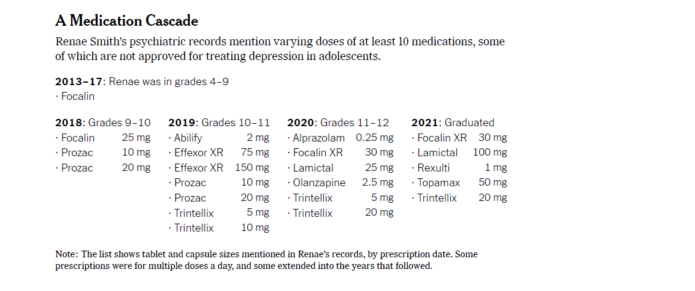
“You can very cogently argue that we don’t have evidence about what it means to be on multiple psychotropic medications,” said Lisa Cosgrove, a clinical psychologist at the University of Massachusetts, Boston. “This is a generation of guinea pigs.”
A study published in 2020 in the journal Pediatrics found that 40.7 percent of people ages 2 to 24 who were prescribed a drug for attention deficit hyperactivity disorder were also prescribed at least one other medication for depression, anxiety, or another mood or behavioral disorder. The study found more than 50 different psychotropic medicines prescribed in such combinations, and a review by The New York Times found that roughly half of the drugs were not approved for use in adolescents, although doctors have discretion to prescribe as they see fit.
Express Scripts, a mail-order pharmacy, recently reported that prescriptions of antidepressants for teenagers rose 38 percent from 2015 to 2019, compared with 12 percent for adults. Prozac and Lexapro are the only medicines approved for teens with depression, according to the Food and Drug Administration, while antidepressants in general carry a “black box warning” about increased risk of suicide for adolescents.

How to Help Teens Struggling With Mental Health

Card 1 of 6
Recognize the signs. Anxiety and depression are different issues but they do share some indicators. Look for changes in a youth’s behavior, such as disinterest in eating or altered sleep patterns. A teen in distress may express excessive worry, hopelessness or profound sadness.
Approach with sensitivity. If you are seeking to start a discussion with a teen who might be struggling, be clear and direct. Don’t shy from hard questions, but also approach the issue with compassion and not blame.
Offer healthy ways to manage emotions. Children who are emotionally struggling are at risk of turning to self-harm to redirect the pain they feel. To prevent that, encourage practices known to help our psychological well-being, such as exercise, meditation and journaling.
Get the correct diagnosis. Find the right doctor for your child by asking for recommendations. Ask the specialist about her experience treating specific conditions in children and the measurement tools she uses to make medical assessments.
Carefully consider medications. Press doctors on their experience treating children with specific drugs and make sure you understand their side effects and interactions with other treatments, as well as how to tell if a medication is working and how hard it is to wean off of it.
Don’t forget the basics. Young people, with developing brains, need eight to 10 hours of sleep to promote mental and physical health. Lack of sleep can interfere with development, and can dramatically impact mood. Physical activity is also vital.
Public health officials first grew concerned about the problem of multiple medication use, or polypharmacy, a decade ago, when it emerged among young people in foster care and low-income settings. Legislative reforms were passed to curb the practice in those settings, but it has since widened to include affluent and middle-class families.
“It’s gone mainstream,” said Julie Zito, professor of pharmacy and psychology at the University of Maryland.

‘Not a Coherent Regimen’
Image
Doctors often “scramble to help a kid who is in their office,” but the lack of clear evidence about what drugs work can lead to educated guesswork and prescription of multiple medications, one expert said.
Ms. Smith’s diagnoses began with inattention.
In fourth grade, she struggled in school and her family sought the help of a psychiatrist, who prescribed Focalin for attention deficit hyperactivity disorder, an increasingly common diagnosis. Looking back at his own high-school days in the early 1980s, her father, Kevin Smith, wonders if he too had suffered from A.D.H.D. He “just zoned out,” he recalled. “It drove my dad nuts.”
Mr. Smith coped a different way, by playing sports, being outdoors and, sometimes, drinking. But his troubles were seen by his own father as a character flaw. “He’d say, ‘Go get in that room, and I’ll hit you a couple of times with the belt. That’ll straighten you out,’” Mr. Smith said.
He vowed not to let his own children suffer any mental health issue unaddressed. “I try vigorously to give Renae all the tools she needs to combat it,” he said.

The Inner Pandemic
Read the full series on the adolescent mental health crisis.
Video

14:46Worried Sick: A Journey Into the Anxious Teenage Mind
Why are so many American teenagers feeling anxious, depressed and even suicidal? Our video looks at the science behind the teen mental health crisis.CreditCredit...The New York Times
In eighth grade Ms. Smith showed signs of depression. “Instead of going to class, I’d go to the guidance counselor and cry for the whole period,” she said. She ventured reasons: Her father’s landscaping business struggled; there were challenges inside the family; she felt pressure to make it to a big-name university, which she saw as the only path to security and happiness. Without entry to a good college, she feared, “I’ll work in a supermarket the rest of my life.”

Her search to feel better led her and her family to various treatments and, eventually, to use of multiple drug prescriptions.
In 2018, in the spring of her freshman year, she visited New Horizon Counseling Center on Long Island. According to her psychiatrist’s notes, which she shared with The Times, Ms. Smith reported experiencing increased anxiety, depression and suicidal ideation. “She agreed to try a small dose of Prozac (10 mg) once a day together with individual therapy,” the doctor wrote. New Horizon did not respond to inquiries from The Times regarding Ms. Smith’s case.
In 10th grade, the same psychiatrist added a prescription for Effexor, an antidepressant that is not approved by the F.D.A. for use in adolescents and that puts teens at increased risk for suicidal behavior and hindered growth.
Later in the year, the psychiatrist added a prescription for Abilify, an antipsychotic drug that is sometimes prescribed for mood disorders but is intended primarily for schizophrenia, which Ms. Smith did not have. He replaced her Prozac with a different antidepressant. Despite the prescriptions, she said, she felt only periods of relief but ultimately became depressed again.
Image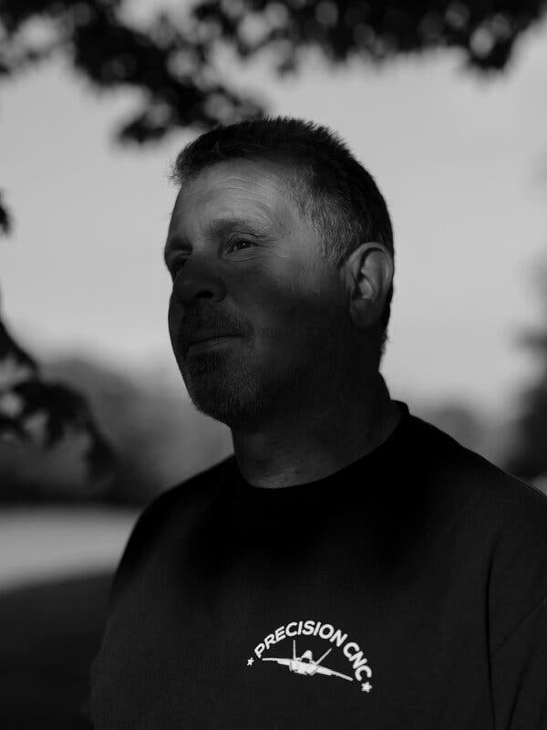
Kevin Smith, Renae’s father, wonders if he too suffered from A.D.H.D. as a high school student in the early 1980s. He “just zoned out,” he recalled. “It drove my dad nuts.”
In May 2020, during the pandemic and 11th grade, Ms. Smith sought treatment at the Mental Health Clinic at Mather Hospital; her original talk therapist had left New Horizon, she said, and her new one there was often over-scheduled and unavailable.
She was prescribed Lamictal at Mather, and then again at New Horizons. “I think it’s a mood stabilizer, I’m not sure,” she said.

Lamictal is primarily intended for adults with bipolar disorder and seizures, neither of which Ms. Smith had been diagnosed with, although some studies have shown its effectiveness in treating other mood disorders. But the drug comes with a black box warning about dangerous skin rashes that in rare cases are life-threatening, noting: “The rate of serious rash is greater in pediatric patients than in adults.”
In December 2020, Ms. Smith started dialectical behavior therapy, an offshoot of cognitive behavioral therapy, at Hofstra University. But the treatment did not involve a psychiatrist to oversee and coordinate medication; in that absence, New Horizons continued to prescribe Ms. Smith’s drugs.
The drug regimen mounted. Over the course of her high school years, Ms. Smith was prescribed 10 different psychotropic medications, not always simultaneously but in overlapping periods, her medical records show.
In 2021, the year she graduated, New Horizon was prescribing her seven: Focalin; Trintellix; alprazolam, an anti-anxiety drug known to be addictive; Lamictal and Topamax, a combination of seizure and migraine medication that can be used to stabilize mood; Rexulti, an “add-on” drug for adults who have major depressive disorder; and olanzapine, a drug used mainly for bipolar disorder and schizophrenia. (Ms. Smith said she was told that olanzapine would dull the side effects of the other medications and help her sleep.)
“I can’t think of any disorder that would result in her being on all these classes of medications,” said Dr. Mark Olfson, clinical psychiatrist at Columbia University and one of several experts whom The Times consulted about Ms. Smith’s drug regimen. They all expressed similar concerns. “It’s not a coherent regimen,” Dr. Olfson said.
But, he added, the practice of overprescribing was common among doctors: “When they’re searching for something that makes the patient symptom-free, they create problems that can result in what is politely called pharmaceutical misadventure.”
ADVERTISEMENT
Continue reading the main story

The Rise of Polypharmacy
Image
Ms. Smith’s high school on Long Island.

The path toward polypharmacy often starts with drugs that are used to treat A.D.H.D. The condition is the “foundation of polypharmacy,” said Dr. David Lohr, a child psychiatrist at the University of Louisville and the medical director for the Department for Community Based Services, which oversees Kentucky’s child welfare system.
A.D.H.D. medications are prescribed widely and considered to be a relatively risk-free way to improve focus. But Dr. Lohr explained that when one medication doesn’t resolve all the issues — or when new ones crop up — parents and doctors can be quick to add additional medications instead of relying on nonpharmacological solutions such as therapy. And A.D.H.D. drugs can have side effects, including sleeplessness, that doctors sometimes treat with additional prescriptions.
New psychiatric drug options began flooding onto the market in the 1980s, with the introduction of second-generation antipsychotics and new classes of antidepressants known as selective serotonin reuptake inhibitors. Another class, serotonin and norepinephrine reuptake inhibitors, came in the 1990s.
A nationwide study published in 2006 examined records of visits to doctors’ offices by people younger than 20 and found a sharp rise in office visits involving the prescription of antipsychotic drugs — to 1.2 million in 2002 from 200,000 in 1993. The drugs increasingly were prescribed in combinations, particularly among low-income children. Between 2004 and 2008, a national study of children enrolled in Medicaid found that 85 percent of patients on an antipsychotic drug were also prescribed a second medication, with the highest rates among disabled youngsters and those in foster care.
Moreover, “the meds don’t work all that well,” said Dr. Robert Hilt, a psychiatrist at the University of Washington. He noted that studies have shown only a modest upside for some of the major classes of medications, including antidepressants, prescribed to adolescents.
Dr. Joshua Gordon, director of the National Institute of Mental Health, said that doctors often “scramble to help a kid who is in their office,” but that the lack of clear evidence about what drugs work can lead to educated guesswork and prescription of multiple medications. “Why kids end up on multiple medications is because we don’t have the medications that are really working for them,” he said. “All of it suggests we need more research.”
Image
Ms. Smith’s handwritten description of a period of despair. “I felt like my mind was going to explode,” she wrote.
Nonetheless, many experts emphasized that the proper use of the right medications can be essential in helping to stabilize an adolescent who is clinically anxious, depressed, self-harming, suicidal or inattentive.
“Medication is important,” said Dr. Stephanie Kennebeck, a pediatric emergency room doctor at Cincinnati Children’s Hospital who has studied therapeutic approaches to suicidal impulses. Also vital, she said, was “knowing that medication has its limitations. Therapy is the cornerstone of what we try to get kids into.”
Polypharmacy became even more common after 2013, when the clinical definition of A.D.H.D. was updated and broadened. Previously, the Diagnostic and Statistical Manual of Mental Disorders, the standard reference for the diagnosis of thousands of medical conditions, stated that an A.D.H.D. diagnosis applied if the patient exhibited “some hyperactive-impulsive or inattentive symptoms that caused impairment.”
In 2013, the requirement for impairment was dropped, among other changes that together “led to significantly increased diagnosis,” according to an analysis in The Journal of the American Medical Association. By 2015 to 2016, 13.1 percent of adolescents ages 12 to 17 were diagnosed with A.D.H.D., according to the journal’s analysis.
Instances of polypharmacy do not always begin with a diagnosis of A.D.H.D. Last summer, Jean, 22, who is being identified by her middle name to protect her privacy, grew increasingly agitated and depressed before her senior year in college.
By April of this year she was taking seven psychiatric medicines. They included lamotrigine, an anti-epileptic drug used for mood; hydroxyzine, gabapentin and propranolol for anxiety; escitalopram, an antidepressant; mirtazapine to treat major depressive disorder; and lithium carbonate, for general mood disorders, although it is also used to treat bipolar disorder, which Jean has not been diagnosed with.
Later that month, Jean confided in group counseling that she thought she might be suicidal. She was subsequently prescribed three more medications, including quetiapine, an antipsychotic used to treat schizophrenia, among other disorders.

When Jean went to the pharmacy to pick up the full array of psychiatric prescriptions, the pharmacist stepped out from behind the counter.
“Are you sure?” the pharmacist asked, according to Jean’s parents. “Is this all for you?”

‘Is This All for You?’
A 22-year-old named Jean was prescribed multiple psychiatric medications this year for anxiety and depression.

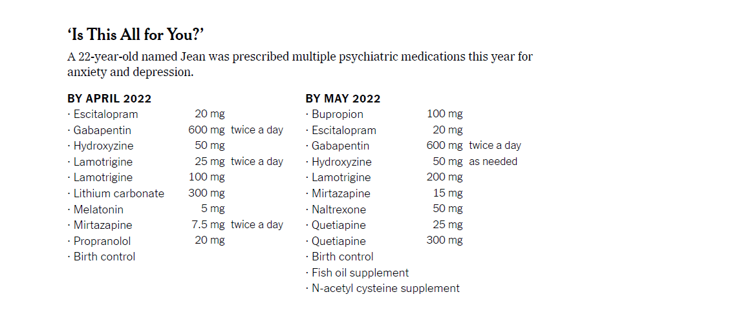
Some health experts worry that in some cases, psychiatric drugs are being prescribed to dull the angst that is part of adolescence. The result is “the medicalization of adolescence,” Dr. Zito, of the University of Maryland, said.
“It’s runaway,” she said.

A New Outlook
Image
Ms. Smith this past May. She hopes to enroll in four-year college to study environmental and wildlife sciences.

In October of 2021, doctors discovered cancer in Ms. Smith’s thyroid. Surgery to remove the tumor was scheduled for this past April.
Over the winter, she found a new psychiatrist who, Ms. Smith said, could spend more time with her than her psychiatrist at New Horizon had been able to do.
Ms. Smith said that under the care of the new psychiatrist, she began cutting back on the drug regimen she had previously been prescribed. By the time of her surgery, she was down to two daily psychiatric drugs, one for A.D.H.D. and one for depression, and also took an anti-anxiety pill once a week or so when symptoms flared.

Her new psychiatrist told her that medications could only do so much. “They help with irrational stress and irrational depression,” Ms. Smith recalled the new doctor telling her, and that “taking antidepressants isn’t going to make you less sad if someone you care about dies.”
The thyroid surgery in April was a success. By midsummer, Ms. Smith said, she felt happier more often. “I do think the medication is working,” she said, but she also credited “internal work,” self-reflection and the cancer diagnosis. It “opened my eyes,” she said. “The things you think are so important just kind of dissipate.”
Her definition of success has changed. too. Whereas she had once thought about “being a doctor or a lawyer or things like that,” she said, now she works in a plant nursery and is applying to a four-year college with a focus on environmental and wildlife sciences.
“I like working with my hands,” Ms. Smith said. “I don’t want to work at a desk, and that’s what I thought I should be doing.” She added, “I’m not the same person that I was a year ago.”
Kerry Lester Kasper contributed reporting.

