The Heart Miracle in Buenos Aires
By our South American correspondent.

On August 18, 1996 in the Church of Santa María in Almagro, Buenos Aires, Argentina, the start of a miracle occurred. A consecrated Host (bread) had been desecrated on a candle holder in the back of the Church. Unable to consume the Host, the priest, Fr. Pezet put it into a glass of water into the tabernacle so that it would dissolve.
When he opened the tabernacle on August 26, he saw that the Host had been transformed into a piece of bloody tissue which was much larger than the original Host. When Fr. Pezet informed Archbishop Bergoglio (now Pope Francis) of the occurrence, the archbishop asked him to have the Host professionally photographed.
After three years, the bloody tissue had not decomposed. Archbishop Bergoglio asked that the bloody tissue be scientifically examined. The analyzed material has been shown to be a fragment of the heart muscle found in the wall of the left ventricle close to the valves.

Another miracle occurred in Buenos Aires in October 2020. A 66yr old volunteer, number 12315632 in Pfizer’s Comirnaty vaccine trial had received his second vaccination of BNT162b2 (30 μg) on 19th September in the city’s Hospital Militar. 29 days later he was admitted to hospital with chest pain.
According to the adverse events file released by FDA to PHMPT he had an adverse event of “Pericarditis” grade 2, deemed not related to the vaccine. It apparently did not resolve.

It was then that the miracle occurred.
The diagnosis of pericarditis was transmuted into “suspected covid-19”. This is despite three negative covid swab tests.
The narrative for the same event is reproduced below:

Subject C4591001 1231 12315632, a 66-year-old white male with no reported medical history, received Dose 1 on 31 Aug 2020 and Dose 2 on 19 Sep 2020 (Day 20). The subject reported suspected (but not confirmed) COVID-19 on 17 Oct 2020, 28 days after receiving Dose 2.
On 17 Oct 2020 (Day 48) the subject experienced left shoulder and arm pain. On 18 Oct 2020 (Day 49), at 01:00 AM the subject experienced chest pain and dyspnea and called the emergency system. He was taken to the emergency room by ambulance where they performed: electrocardiogram with no ischemic changes, chest x-ray with unknown results, chest computerized tomogram that showed pneumonia of unknown localization. At the time of reporting the subject had presented with a temperature of 38°C. Blood/laboratory tests were done but results were unreported. In accordance with the hospital COVID-19 pandemic protocol the subject had a SARS-CoV-2 reverse transcription polymerase chain reaction (RT-PCR) swab. The date of discharge from hospital is unknown, however, the site received a discharge summary on 20 Oct 2020 (Day 51) stating the result of the SARS-CoV2 RT-PCR swab was negative. The swab taken for the purposes of the study and analyzed at the central laboratory was also negative. An additional SARS-CoV-2 test performed locally on 28 Oct 2020 was also negative. The cause of the potential COVID-19 illness remains unknown as no other microbiological studies were performed. The suspected (but not confirmed) COVID-19 illness was ongoing at the time of the last available report. In the opinion of the investigator, there was no reasonable possibility that the suspected COVID-19 was related to the study intervention or clinical trial procedures. Pfizer concurred with the investigator’s causality assessment.

This miracle will ring true with Augusto Roux, whose hospital-confirmed vaccine-induced adverse reaction of pericarditis similarly disappeared into “suspected covid” and then “severe anxiety”. We are fairly certain that the iTRIALS team led by Fernando Polack were responsible for this transformation.

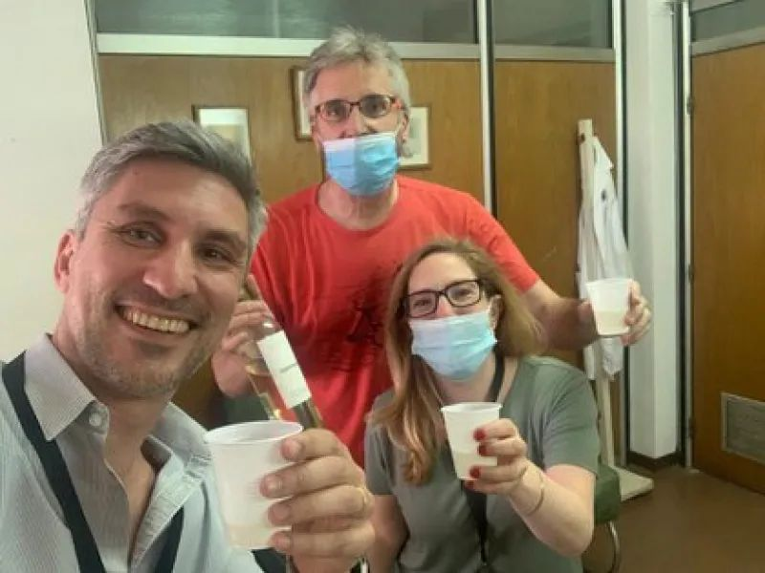
Another iTRIALS miracle: water into wine?

Unless they have had a change of heart, we think Drs Fernando Polack and Stephen Thomas (coordinating principal investigator) would want to know about this (second) accidentally overlooked instance of pericarditis in Pfizer’s Argentine trial center, so will be sending them a friendly email and will share their replies here in due course
__________________________________

Give my heart just a word of sympathy
Be as fair to my heart as you can be
Then if you no longer care
For the love that's beating there
Take these chains from my heart and set me free.
Ray Charles

